Spring REST using Spring Boot
- spring-rest-handson

SpringLearnApplication.java
package com.example.spring_learn;

import org.springframework.boot.SpringApplication;
import org.springframework.boot.autoconfigure.SpringBootApplication;
import org.slf4j.Logger;
import org.slf4j.LoggerFactory;

@SpringBootApplication
public class SpringLearnApplication {

private static final Logger LOGGER = LoggerFactory.getLogger(SpringLearnApplication.class);

public static void main(String[] args) {
LOGGER.info("Inside main()");
SpringApplication.run(SpringLearnApplication.class, args);
}
}

application.properties
server.port=8082
logging.level.root=INFO
logging.level.com.cognizant=DEBUG
logging.pattern.console=%d{yyyy-MM-dd HH:mm:ss} - %msg%n

SpringLearnApplicationTests.java
package com.example.spring_learn;

import org.junit.jupiter.api.Test;
import org.springframework.boot.test.context.SpringBootTest;

@SpringBootTest
class SpringLearnApplicationTests {

@Test
void contextLoads() {
}

}

OUTPUT

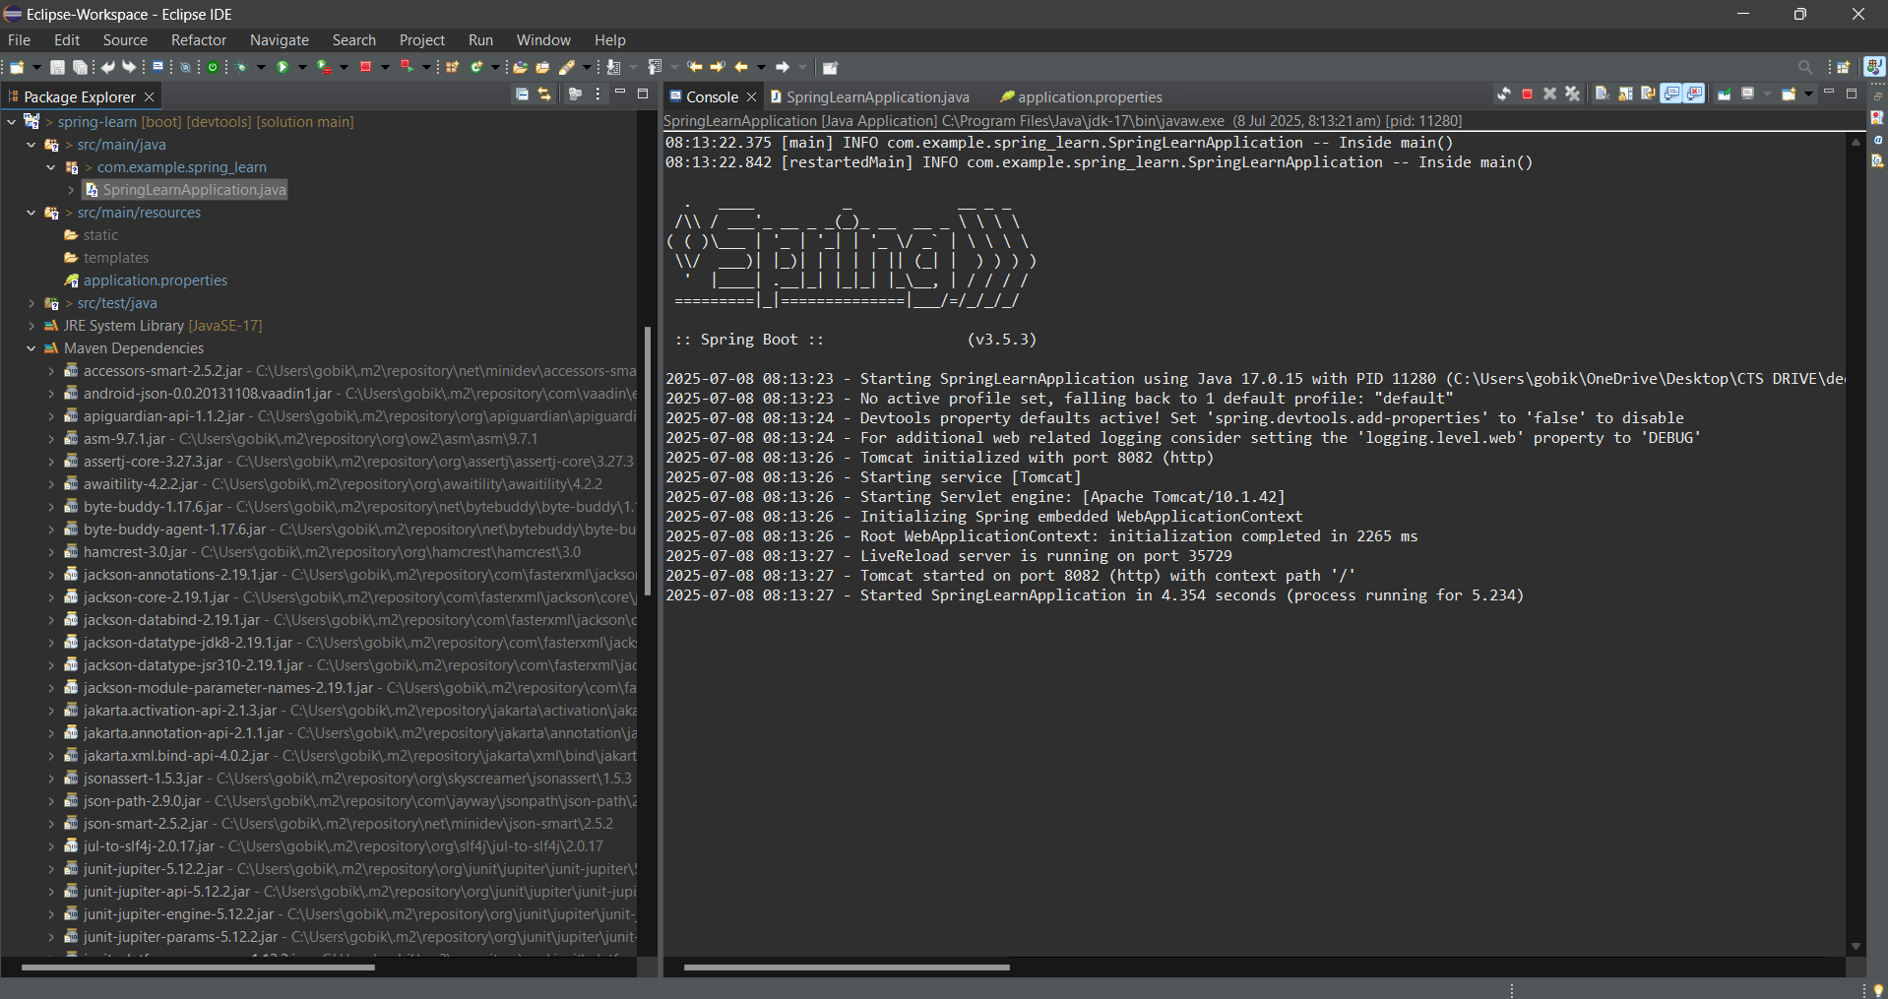

- Spring Core – Load SimpleDateFormat from Spring Configuration XML

SpringLearn2Application.java
package com.cognizant.spring_learn_2;

import java.text.ParseException;
import java.text.SimpleDateFormat;
import java.util.Date;

import org.springframework.context.ApplicationContext;
import org.springframework.context.support.ClassPathXmlApplicationContext;
import org.springframework.boot.SpringApplication;
import org.springframework.boot.autoconfigure.SpringBootApplication;

@SpringBootApplication
public class SpringLearn2Application {

public static void main(String[] args) throws ParseException {
SpringApplication.run(SpringLearn2Application.class, args);
displayDate();
}

public static void displayDate() throws ParseException {
ApplicationContext context = new ClassPathXmlApplicationContext("date-format.xml");
SimpleDateFormat format = context.getBean("dateFormat", SimpleDateFormat.class);

Date date = format.parse("31/12/2018");
System.out.println("Parsed Date: " + date);
}
}

application.properties

spring.application.name=spring_learn_2
server.port=8088

date-format.xml

<?xml version="1.0" encoding="UTF-8"?>
<beans xmlns="http://www.springframework.org/schema/beans"
xmlns:xsi="http://www.w3.org/2001/XMLSchema-instance"
xsi:schemaLocation="http://www.springframework.org/schema/beans
https://www.springframework.org/schema/beans/spring-beans.xsd">

<bean id="dateFormat" class="java.text.SimpleDateFormat">
<constructor-arg value="dd/MM/yyyy" />
</bean>

</beans>

SpringLearn2ApplicationTests.java

package com.cognizant.spring_learn_2;

import org.junit.jupiter.api.Test;
import org.springframework.boot.test.context.SpringBootTest;

@SpringBootTest
class SpringLearn2ApplicationTests {

@Test
void contextLoads() {
}

}

OUTPUT

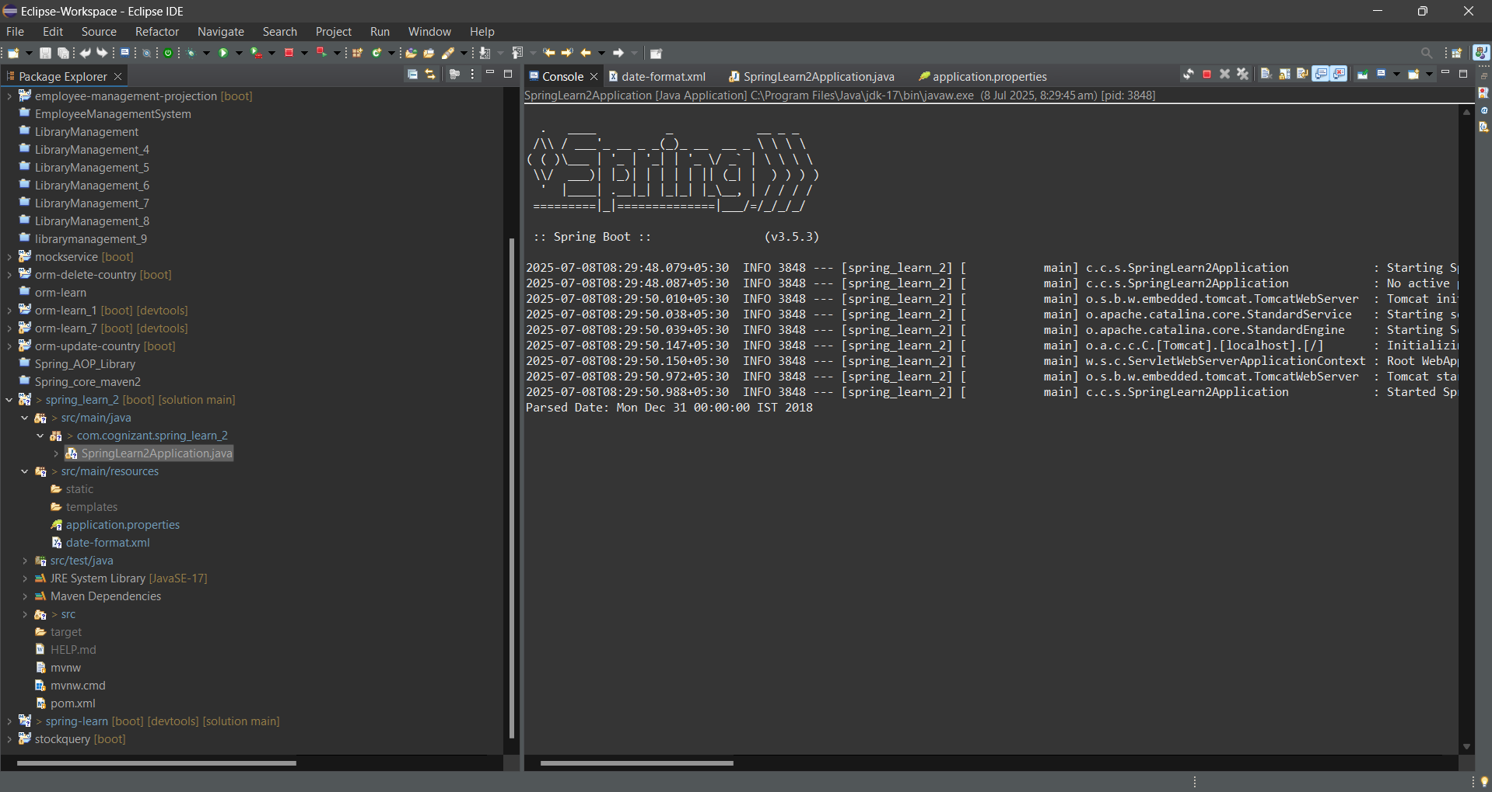

- Spring Core - Incorporate Logging
SpringLearn3Application.java
package com.cognizant.spring_learn_3;

import org.slf4j.Logger;
import org.slf4j.LoggerFactory;
import org.springframework.boot.autoconfigure.SpringBootApplication;
import org.springframework.boot.SpringApplication;
import org.springframework.context.ApplicationContext;
import org.springframework.context.support.ClassPathXmlApplicationContext;

import java.text.SimpleDateFormat;
import java.util.Date;

@SpringBootApplication
public class SpringLearn3Application {

private static final Logger LOGGER = LoggerFactory.getLogger(SpringLearn3Application.class);

public static void main(String[] args) {
LOGGER.info("START - main()");
SpringApplication.run(SpringLearn3Application.class, args);
displayDate();
LOGGER.info("END - main()");
}

public static void displayDate() {
LOGGER.info("START - displayDate()");
ApplicationContext context = new ClassPathXmlApplicationContext("date-format.xml");

SimpleDateFormat format = context.getBean("dateFormat", SimpleDateFormat.class);

try {
Date date = format.parse("31/12/2018");
LOGGER.debug("Parsed Date: {}", date);
} catch (Exception e) {
LOGGER.error("Date parsing failed", e);
}

LOGGER.info("END - displayDate()");
}
}
application.properties
server.port=8089

logging.level.org.springframework=info
logging.level.com.cognizant.spring_learn_3=debug

logging.pattern.console=%d{yyMMdd}|%d{HH:mm:ss.SSS}|%-20.20thread|%5p|%-25.25logger{25}|%25M|%m%n
date-format.xml
<?xml version="1.0" encoding="UTF-8"?>
<beans xmlns="http://www.springframework.org/schema/beans"
xmlns:xsi="http://www.w3.org/2001/XMLSchema-instance"
xsi:schemaLocation="http://www.springframework.org/schema/beans
https://www.springframework.org/schema/beans/spring-beans.xsd">

<bean id="dateFormat" class="java.text.SimpleDateFormat">
<constructor-arg value="dd/MM/yyyy" />
</bean>

</beans>

SpringLearn3ApplicationTests.java
package com.cognizant.spring_learn_3;

import org.junit.jupiter.api.Test;
import org.springframework.boot.test.context.SpringBootTest;

@SpringBootTest
class SpringLearn3ApplicationTests {

@Test
void contextLoads() {
}
}

OUTPUT
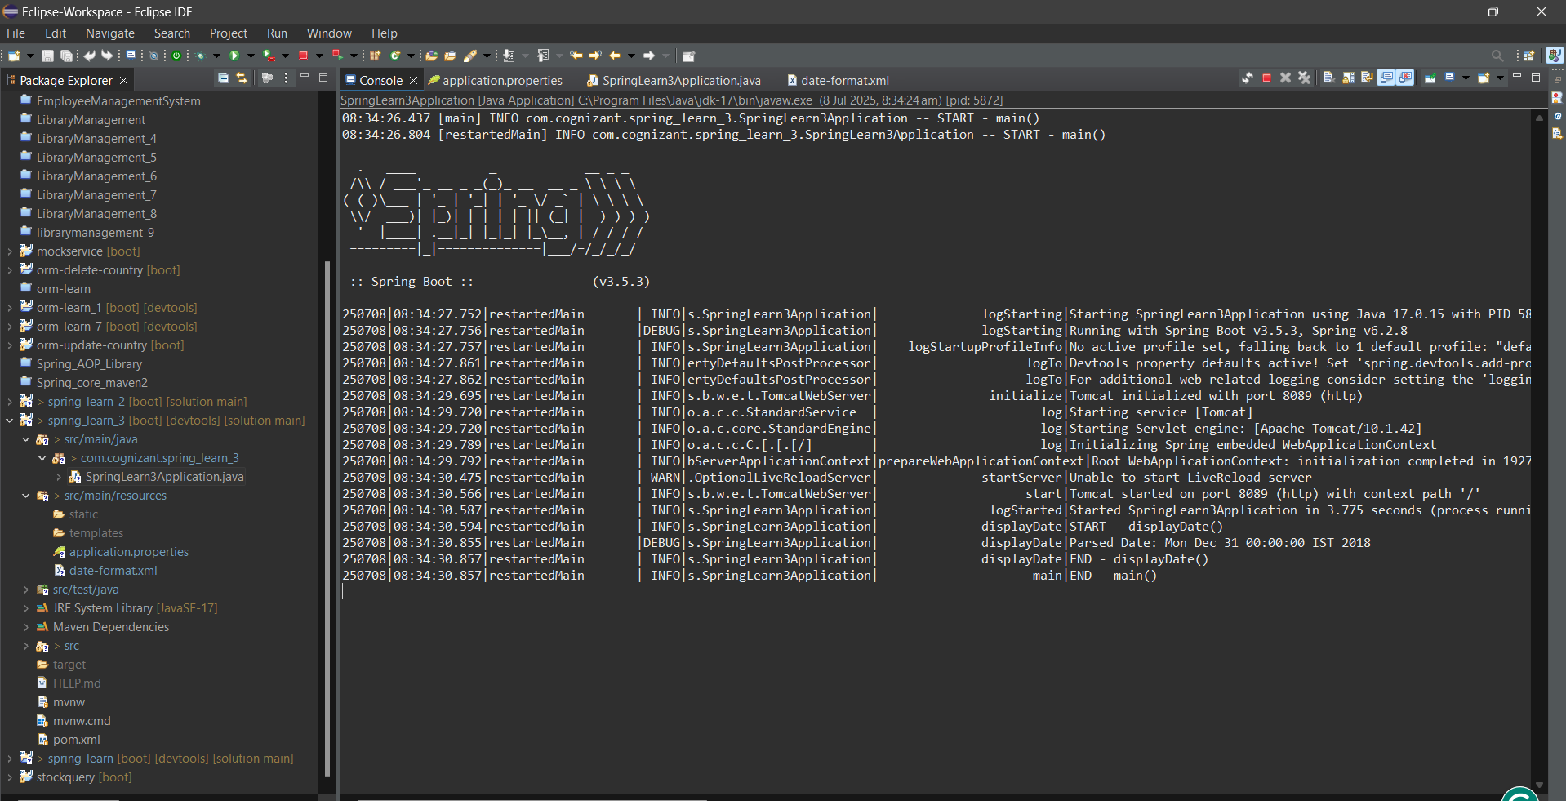
- Spring Core – Load Country from Spring Configuration XML
Country.java
package com.cognizant.spring_learn_4;

import org.slf4j.Logger;
import org.slf4j.LoggerFactory;

public class Country {
private static final Logger LOGGER = LoggerFactory.getLogger(Country.class);

private String code;
private String name;

public Country() {
LOGGER.debug("Inside Country Constructor.");
}

public String getCode() {
LOGGER.debug("getCode() called");
return code;
}

public void setCode(String code) {
LOGGER.debug("setCode() called");
this.code = code;
}

public String getName() {
LOGGER.debug("getName() called");
return name;
}

public void setName(String name) {
LOGGER.debug("setName() called");
this.name = name;
}

@Override
public String toString() {
return "Country [code=" + code + ", name=" + name + "]";
}
}

SpringLearn4Application.java

package com.cognizant.spring_learn_4;

import org.slf4j.Logger;
import org.slf4j.LoggerFactory;
import org.springframework.boot.autoconfigure.SpringBootApplication;
import org.springframework.boot.SpringApplication;
import org.springframework.context.ApplicationContext;
import org.springframework.context.support.ClassPathXmlApplicationContext;

@SpringBootApplication
public class SpringLearn4Application {

private static final Logger LOGGER = LoggerFactory.getLogger(SpringLearn4Application.class);

public static void main(String[] args) {
LOGGER.info("START - main()");
SpringApplication.run(SpringLearn4Application.class, args);
displayCountry();
LOGGER.info("END - main()");
}

public static void displayCountry() {
LOGGER.info("START - displayCountry()");
ApplicationContext context = new ClassPathXmlApplicationContext("country.xml");
Country country = context.getBean("country", Country.class);
LOGGER.debug("Country: {}", country.toString());
LOGGER.info("END - displayCountry()");
}
}

application.properties

server.port=8085

logging.level.org.springframework=info
logging.level.com.cognizant.spring_learn_4=debug

logging.pattern.console=%d{yyMMdd}|%d{HH:mm:ss.SSS}|%-20.20thread|%5p|%-25.25logger{25}|%25M|%m%n

country.xml
<?xml version="1.0" encoding="UTF-8"?>
<beans xmlns="http://www.springframework.org/schema/beans"
xmlns:xsi="http://www.w3.org/2001/XMLSchema-instance"
xsi:schemaLocation="http://www.springframework.org/schema/beans
https://www.springframework.org/schema/beans/spring-beans.xsd">

<bean id="country" class="com.cognizant.spring_learn_4.Country">
<property name="code" value="IN" />
<property name="name" value="India" />
</bean>

</beans>

SpringLearn4ApplicationTests.java
package com.cognizant.spring_learn_4;

import org.junit.jupiter.api.Test;
import org.springframework.boot.test.context.SpringBootTest;

@SpringBootTest
class SpringLearn4ApplicationTests {

@Test
void contextLoads() {
}

}

OUTPUT

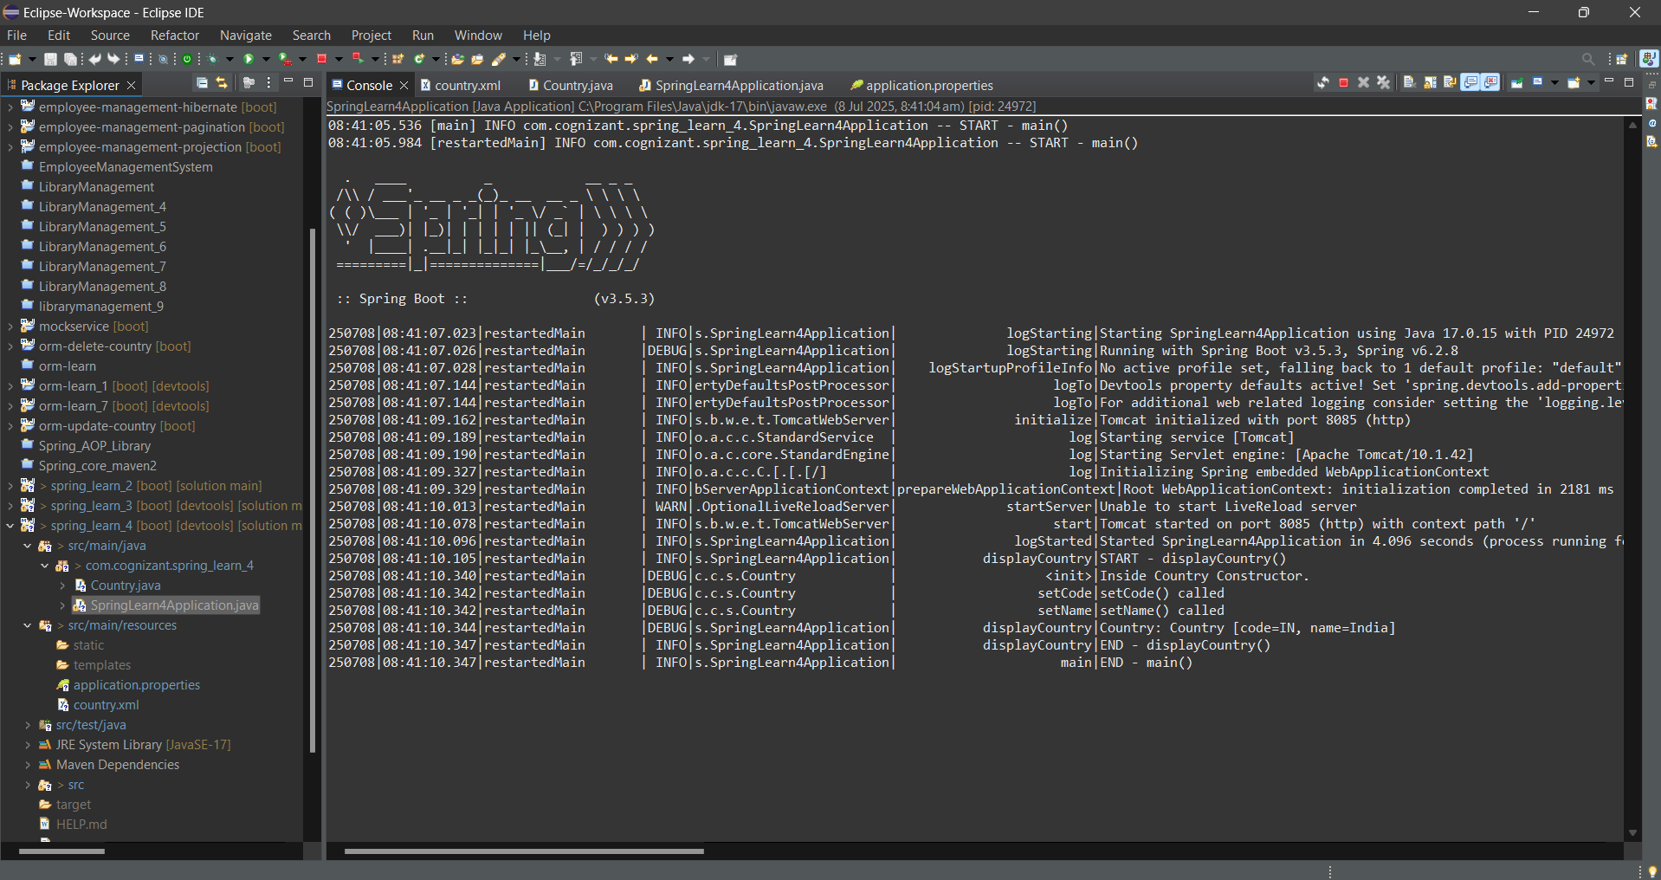

- Spring Core – Demonstration of Singleton Scope and Prototype Scope

Country.java
package com.cognizant.spring_learn_5;

import org.slf4j.Logger;
import org.slf4j.LoggerFactory;

public class Country {
private static final Logger LOGGER = LoggerFactory.getLogger(Country.class);

private String code;
private String name;

public Country() {
LOGGER.debug("Inside Country Constructor");
}

public String getCode() {
LOGGER.debug("getCode() called");
return code;
}

public void setCode(String code) {
LOGGER.debug("setCode() called");
this.code = code;
}

public String getName() {
LOGGER.debug("getName() called");
return name;
}

public void setName(String name) {
LOGGER.debug("setName() called");
this.name = name;
}

@Override
public String toString() {
return "Country [code=" + code + ", name=" + name + "]";
}
}

SpringLearn5Application.java

package com.cognizant.spring_learn_5;

import org.slf4j.Logger;
import org.slf4j.LoggerFactory;
import org.springframework.boot.autoconfigure.SpringBootApplication;
import org.springframework.boot.SpringApplication;
import org.springframework.context.ApplicationContext;
import org.springframework.context.support.ClassPathXmlApplicationContext;

@SpringBootApplication
public class SpringLearn5Application {

private static final Logger LOGGER = LoggerFactory.getLogger(SpringLearn5Application.class);

public static void main(String[] args) {
LOGGER.info("START main()");
SpringApplication.run(SpringLearn5Application.class, args);
displayCountry();
LOGGER.info("END main()");
}

public static void displayCountry() {
LOGGER.info("START displayCountry()");

ApplicationContext context = new ClassPathXmlApplicationContext("country.xml");

Country country1 = context.getBean("country", Country.class);
LOGGER.debug("First Country Object: {}", country1);

Country country2 = context.getBean("country", Country.class);
LOGGER.debug("Second Country Object: {}", country2);

LOGGER.info("Are both objects same? : {}", country1 == country2);

LOGGER.info("END displayCountry()");
}
}

application.properties

server.port=8087

logging.level.org.springframework=info
logging.level.com.cognizant.spring_learn_5=debug

logging.pattern.console=%d{yyMMdd}|%d{HH:mm:ss.SSS}|%-20.20thread|%5p|%-25.25logger{25}|%25M|%m%n

country.xml
<?xml version="1.0" encoding="UTF-8"?>
<beans xmlns="http://www.springframework.org/schema/beans"
xmlns:xsi="http://www.w3.org/2001/XMLSchema-instance"
xsi:schemaLocation="http://www.springframework.org/schema/beans
https://www.springframework.org/schema/beans/spring-beans.xsd">

<bean id="country" class="com.cognizant.spring_learn_5.Country" scope="prototype">
<property name="code" value="IN" />
<property name="name" value="India" />
</bean>

</beans>

SpringLearn5ApplicationTests.java

package com.cognizant.spring_learn_5;

import org.junit.jupiter.api.Test;
import org.springframework.boot.test.context.SpringBootTest;

@SpringBootTest
class SpringLearn5ApplicationTests {

@Test
void contextLoads() {
}

}

OUTPUT

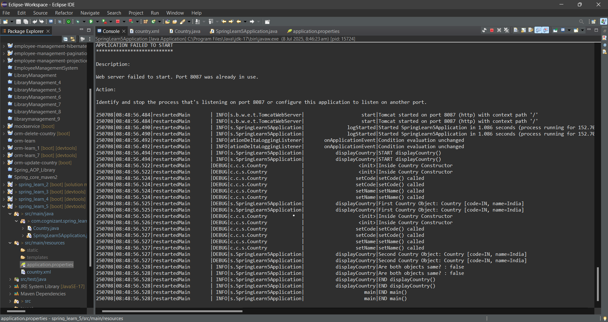

- Spring Core – Load list of countries from Spring Configuration XML

Country.java
package com.cognizant.spring_learn_6;

import org.slf4j.Logger;
import org.slf4j.LoggerFactory;

public class Country {
private static final Logger LOGGER = LoggerFactory.getLogger(Country.class);

private String code;
private String name;

public Country() {
LOGGER.debug("Inside Country Constructor");
}

public String getCode() {
LOGGER.debug("getCode() called");
return code;
}

public void setCode(String code) {
LOGGER.debug("setCode() called");
this.code = code;
}

public String getName() {
LOGGER.debug("getName() called");
return name;
}

public void setName(String name) {
LOGGER.debug("setName() called");
this.name = name;
}

@Override
public String toString() {
return "Country [code=" + code + ", name=" + name + "]";
}
}

SpringLearn6Application.java

package com.cognizant.spring_learn_6;

import org.slf4j.Logger;

import org.slf4j.LoggerFactory;

import org.springframework.boot.autoconfigure.SpringBootApplication;

import org.springframework.boot.SpringApplication;

import org.springframework.context.ApplicationContext;

import org.springframework.context.support.ClassPathXmlApplicationContext;

import java.util.List;

@SpringBootApplication

public class SpringLearn6Application {

private static final Logger LOGGER = LoggerFactory.getLogger(SpringLearn6Application.class);

public static void main(String[] args) {

LOGGER.info("START main()");

SpringApplication.run(SpringLearn6Application.class, args);

displayCountries();

LOGGER.info("END main()");

}

public static void displayCountries() {

LOGGER.info("START displayCountries()");

ApplicationContext context = new ClassPathXmlApplicationContext("country.xml");

@SuppressWarnings("unchecked")

List<Country> countries = (List<Country>) context.getBean("countryList");

for (Country country : countries) {

LOGGER.debug("Country : {}", country);

}

LOGGER.info("END displayCountries()");

}

}
application.properties
server.port=8080

logging.level.org.springframework=info
logging.level.com.cognizant.spring_learn_6=debug

logging.pattern.console=%d{yyMMdd}|%d{HH:mm:ss.SSS}|%-20.20thread|%5p|%-25.25logger{25}|%25M|%m%n
country.xml
<?xml version="1.0" encoding="UTF-8"?>
<beans xmlns="http://www.springframework.org/schema/beans"
xmlns:xsi="http://www.w3.org/2001/XMLSchema-instance"
xsi:schemaLocation="http://www.springframework.org/schema/beans
https://www.springframework.org/schema/beans/spring-beans.xsd">

<bean id="in" class="com.cognizant.spring_learn_6.Country">
<property name="code" value="IN" />
<property name="name" value="India" />
</bean>

<bean id="us" class="com.cognizant.spring_learn_6.Country">
<property name="code" value="US" />
<property name="name" value="United States" />
</bean>

<bean id="de" class="com.cognizant.spring_learn_6.Country">
<property name="code" value="DE" />
<property name="name" value="Germany" />
</bean>

<bean id="jp" class="com.cognizant.spring_learn_6.Country">
<property name="code" value="JP" />
<property name="name" value="Japan" />
</bean>

<bean id="countryList" class="java.util.ArrayList">
<constructor-arg>
<list>
<ref bean="in" />
<ref bean="us" />
<ref bean="de" />
<ref bean="jp" />
</list>
</constructor-arg>
</bean>

</beans>

SpringLearn6ApplicationTests.java
package com.cognizant.spring_learn_6;

import org.junit.jupiter.api.Test;
import org.springframework.boot.test.context.SpringBootTest;

@SpringBootTest
class SpringLearn6ApplicationTests {

@Test
void contextLoads() {
}

}
OUTPUT
